CREATE A FORM

**IBM-Project-43746-1660719180**

DATE:04-11-2022

TEAM ID: PNT2022TMID33439

Connecting nodes using node-red:

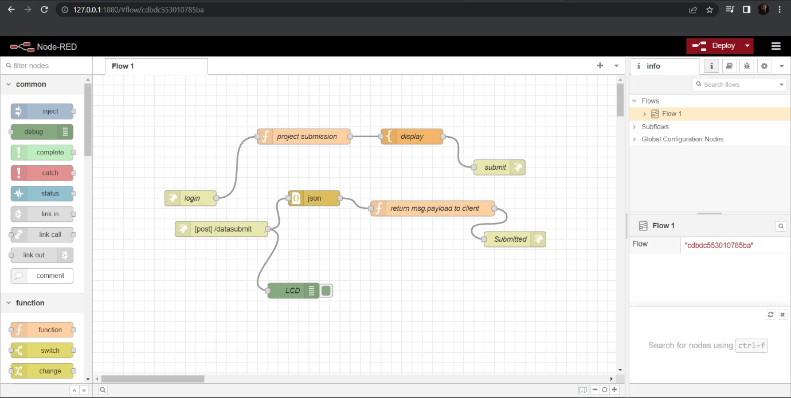

After deploying the nodes:

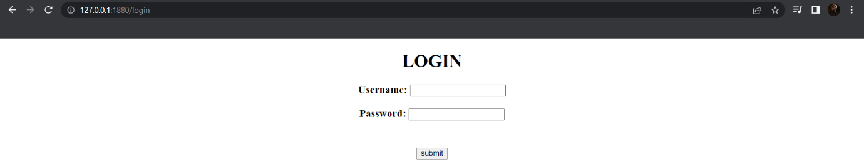

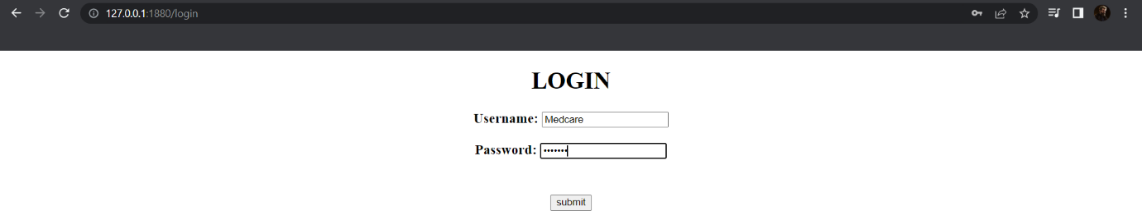

After clicking on Submit button:

